

Amazix — March Blog Post #8

16 June 2021

Prepared by AmaZix

Tips and Tricks of the Trade — Content Marketing 101 With AmaZix

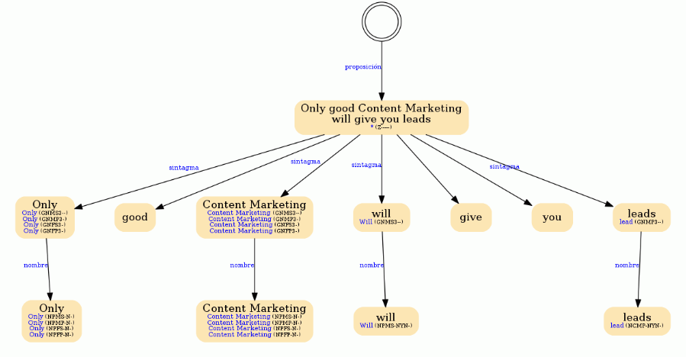

Source: <https://www.mystilus.com/en/tools/morphosyntactic-analyzer>

A blank white page is always imposing. That’s why some of us have our text editor configured in light blue.

But many things happen before the first letter is written. In this article, we will talk about all the preparation that makes content flow as intended.

What? Who? How? Angle? Focus? Many questions arise when planning an article, and the answer for most of them at first is usually the same: «Let me grab a coffee, and I’ll be right back.» Maybe that’s because there are questions that we are missing. Questions that are answered by [content marketing](https://www.amazix.com/blogs/post/Content-is-king-even-for-blockchain-projects).

# Filling the Void

An article is, above all, a story. It’s the wrapper that makes the content and delivery the best experience for the reader. Just like when you order a shampoo online, you don't get it in a jerrycan, so does the content need to be presented in a way that fits the argument you want to make. But what kind of story do we want to tell? A story about what?

There are many stories to tell in content marketing that help the message get across and hit just the right spot. You have to tell the story of the product, what value it brings, what differentiates it, what its design says, what innovative aspects it brings, what its future is like.

But to hook the reader, imagine their stories about the product, about who they are, what they hate and what they like, the plausible situations they’ve been in, the cultural references they are familiar with, and so much more.

In short, it is about translating technical specifications and data into stories, narratives that reflect who the reader is and what they want.

The story must also be aimed at achieving a goal in line with the predetermined content marketing objective — the reason why the topic was chosen in the first place to make an article, looking at the product, the strategy, and the data.

However, reinforcing a message requires the ability to elaborate on the right measure to put on the table the line of argument that supports the weight of the article. This aspect may be more controversial. After all, we live in the world where TikTok thrives. However, it is not the smaller content that has the greatest impact.

Creating long-form pieces is challenging without a good content marketing strategy behind it. Superior story development requires length as well as decent logical and analytical support. Only exhaustive content will satisfy and teach the reader who has a genuine interest in the approach. This requires a fair prior process of data gathering and properly documenting, and a wide perspective that broadly covers the different aspects of the topic.

## Nurturing Your Content

Let us now move on to post-creation aspects. How do we maximize the content marketing value of the text we have written?

The first stop here is [**SEO optimization**](https://www.amazix.com/blogs/post/why-seo-is-your-secret-weapon), a key item of any content marketing tactics coming to fruition. A very aggressive SEO strategy can cause fluent and pleasant text to be hindered by the constant redundancy of keywords to please the search engines.

We must never forget that it is people who read articles. Search Engine Robots do not.

Sorry, Google Robot, I know you have already read this, but it had to be said.

It is not a matter of dispensing with the tools that are known to work but using them sparingly, producing content with SEO and not SEO with content.

Good articles, moreover, are more than a link. Here too, content marketing strategy comes to your help. It is no less evident that content must be well distributed to reach those readers who might be interested in it and who could become leads in your sales funnel.

A properly created [**Social Media**](https://www.amazix.com/pr-m-smm) **plan** must support your writing efforts — not only for the ability to reach many people but also reach those groups for whom your content marketing ideas are customized and intended. It is also a way to give life and interactivity to the topics raised by making them also topics of media that invite the participation of readers.

And finally, speaking of giving life to the articles, it is also a good practice to resurrect them. **Backlinking (or interlinking)** is an excellent technique to keep an article alive over time. It also works for a current article to better complement the narrative without overextending, just taking advantage of something already developed.

While the goal of content marketing is producing leads, that cannot be achieved if the content feels patchy or incongruent. Even when you have a clear message to communicate, how you do it makes all the difference.

**That’s why so many customers choose us to manage their content production.** [**Contact us**](https://www.amazix.com/contact) **and start making your articles tell your story.**